**SIFT Together with Geometric Constraint Matching**

**Name:** Surya Venkatesh Vijjana

**Student ID:** 1017096070

**Achieved:**

1. DoG (Difference of Gaussian) images for octave images.
2. Identified the Local Maximum’s for octave images and Identified the Key points for both images.
3. Implemented the derivative images functions Ix(), Iy() to generate Ix and Iy images for octaves.
4. Implemented the functions to generate the Direction Image (Id) and Approximation Image (Ia).
5. Generated the Final 8D vectors for keypoints.
6. Normalized the 8D vectors based on the maximum values for a bin.
7. Generated the Feature set (getSift() Function).
8. Calculated NCC for each keyPoints in both Images.

**Not Achieved:**

1. Random selection of 4 pairs of correspondences for homograph Matrix computation.
2. RANSAC process to correctly find optimal matching pairs and assign a matching score between two images

**Issues with the Program:**

1. After getting the Approximation Image (Ia), while generating the 8D vectors (histogram) only a few octaves (for example 1,1/2,1/4 octaves only satisfying the window boundary conditions and able to generate the histogram and couldn't generate histogram for the remaining octaves) have the resized key points so that we can take the 7*7 window and generate the histogram.
2. Because of this reason, I was not able to get 6*8D vectors for each key points and could not complete the later part of the project (Homogeneous Transformation).
3. Because we couldn’t generate the 8D vectors for few key points for some of the octaves, Feature Matrix which is initialized as float type has the default values in it which causes an error in NCC Matching.

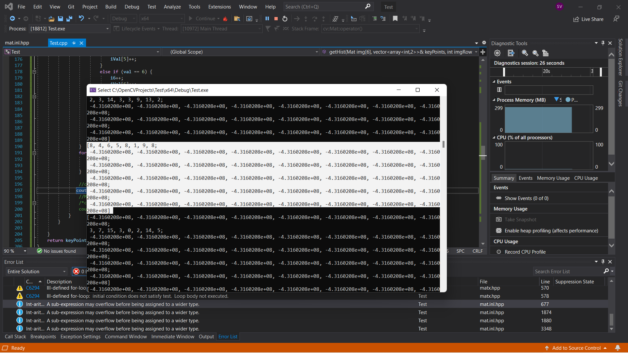

**Highlighted the missing 8D Vectors for few octaves (as we don’t have values for this row, default values were unchanged)**

1. It takes 4-5 mins for code to execute as there are large for-loops involved I pixel comparisons at various stages of the code.